http://alexcline.net/2011/11/15/reconfiguring-network-interfaces-in-centosrhel-systems-cloned-with-vcenter/

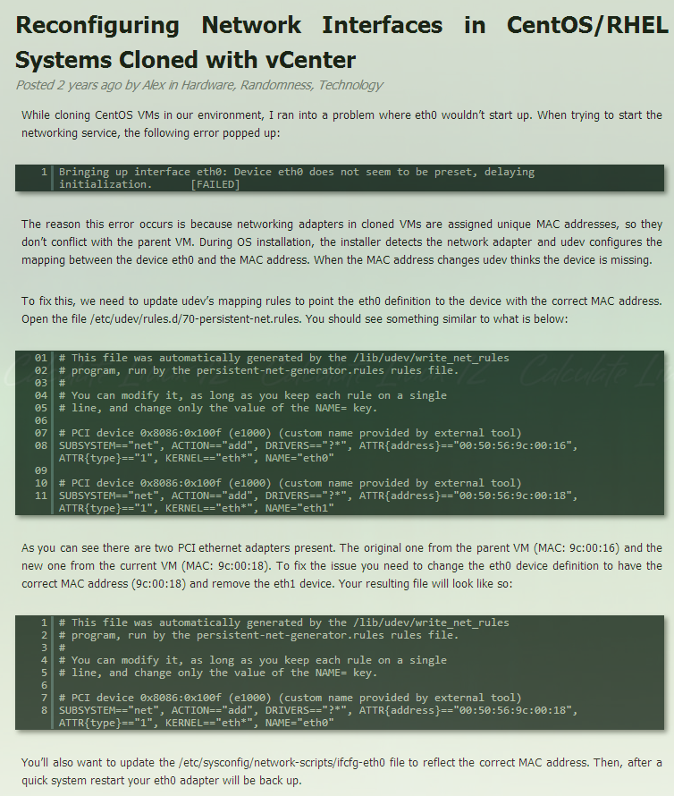

Reconfiguring Network Interfaces in CentOS/RHEL Systems Cloned with vCenter
Posted 2 years ago by Alex in Hardware, Randomness, Technology
While cloning CentOS VMs in our environment, I ran into a problem where eth0 wouldn’t start up. When trying to start the networking service, the following error popped up:
1
Bringing up interface eth0: Device eth0 does not seem to be preset, delaying initialization. [FAILED]
The reason this error occurs is because networking adapters in cloned VMs are assigned unique MAC addresses, so they don’t conflict with the parent VM. During OS installation, the installer detects the network adapter and udev configures the mapping between the device eth0 and the MAC address. When the MAC address changes udev thinks the device is missing.
To fix this, we need to update udev’s mapping rules to point the eth0 definition to the device with the correct MAC address. Open the file /etc/udev/rules.d/70-persistent-net.rules. You should see something similar to what is below:
01
# This file was automatically generated by the /lib/udev/write_net_rules
02
# program, run by the persistent-net-generator.rules rules file.
03
#
04
# You can modify it, as long as you keep each rule on a single
05
# line, and change only the value of the NAME= key.
06

07
# PCI device 0x8086:0x100f (e1000) (custom name provided by external tool)
08
SUBSYSTEM=="net", ACTION=="add", DRIVERS=="?*", ATTR{address}=="00:50:56:9c:00:16", ATTR{type}=="1", KERNEL=="eth*", NAME="eth0"
09

10
# PCI device 0x8086:0x100f (e1000) (custom name provided by external tool)
11
SUBSYSTEM=="net", ACTION=="add", DRIVERS=="?*", ATTR{address}=="00:50:56:9c:00:18", ATTR{type}=="1", KERNEL=="eth*", NAME="eth1"
As you can see there are two PCI ethernet adapters present. The original one from the parent VM (MAC: 9c:00:16) and the new one from the current VM (MAC: 9c:00:18). To fix the issue you need to change the eth0 device definition to have the correct MAC address (9c:00:18) and remove the eth1 device. Your resulting file will look like so:
1
# This file was automatically generated by the /lib/udev/write_net_rules
2
# program, run by the persistent-net-generator.rules rules file.
3
#
4
# You can modify it, as long as you keep each rule on a single
5
# line, and change only the value of the NAME= key.
6

7
# PCI device 0x8086:0x100f (e1000) (custom name provided by external tool)
8
SUBSYSTEM=="net", ACTION=="add", DRIVERS=="?*", ATTR{address}=="00:50:56:9c:00:18", ATTR{type}=="1", KERNEL=="eth*", NAME="eth0"
You’ll also want to update the /etc/sysconfig/network-scripts/ifcfg-eth0 file to reflect the correct MAC address. Then, after a quick system restart your eth0 adapter will be back up.

